Figma Guide

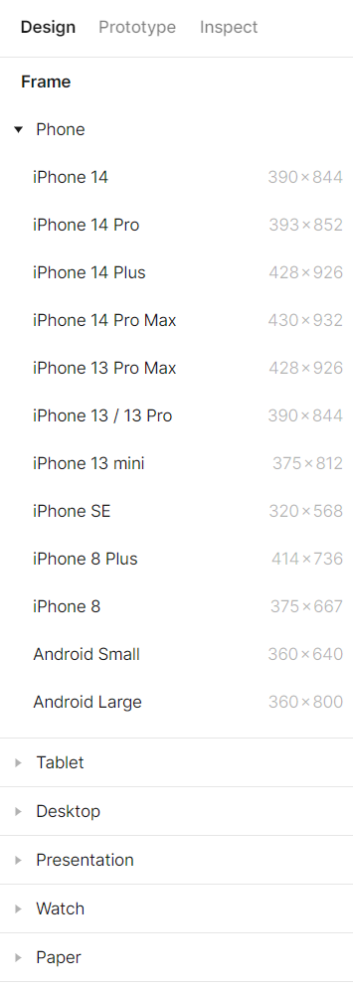**Creating the framework**

1. a Frame is a box that will contain everything on the website.



Pressing this button will allow you to create a frame manually.

It will also bring up these additional options on the side 🡪

You may also press F to pay respek- I mean, to use the frame tool.

1. Creating shapes and inserting images and videos

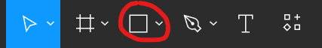

This button will allow you to create shapes.

For more shapes, press the downward arrow on the right.

Doing so will also allow you to insert images and videos.

1. Reuse components

Selecting any object will give you the option to create a component.



Pressing this button on the top will turn the object into a component.

You can then press this button to access the components you have made.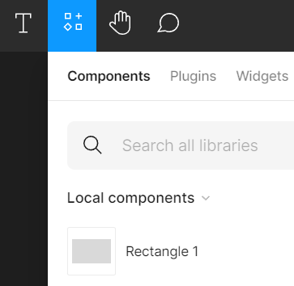

Drag and drop components to reuse them.

1. Changing the design properties of objects

When you click on an object, it will allow you to edit all the design properties of the object.

This includes: alignment of the object, position, color of the object, color of the text, rounded angles, etc.

Additional resources

Figma guides:

Intro to Figma - <https://youtu.be/jk1T0CdLxwU>

Figma Masterclass for Beginners - <https://youtu.be/II-6dDzc-80>

Things to consider when creating a website:

60-30-10 Color Rule - <https://youtu.be/UWwNIMHFdW4>